*ACADEMIC HONESTY*

*AND*

*INTEGRITY POLICY*

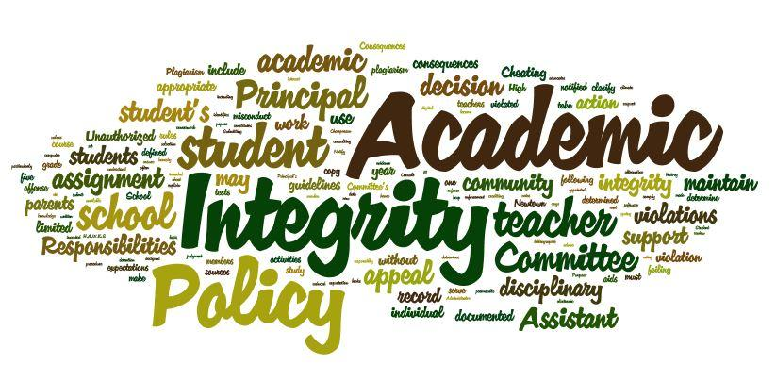

*HEPHZIBAH COMPREHENSIVE HIGH SCHOOL*

**Definitions:**

**Academic Conspiracy or Collusion**-Support the misconduct committed by another student or assisting another in academic dishonesty.

**Cheating-** The use or attempted use of unauthorized assistance during the preparation for or execution of academic work including class work, formative, or summative assessment.

**Dismissal-**The end of the student’s participation in the IB Programme.

**Plagiarism**-Deliberately presenting the ideas or works or statements of another as one’s own, without acknowledgement of the source. Plagiarism includes downloading, copying, and/or buying work and submitting it as the student’s own work.

**Fabrication**-Falsifying any information for academic purposes. This information is not solely for assessment purposes; this includes falsifying documentation in order to postpone assessments or to request an extension for assignments.

**Malpractice-**All behaviors resulting in a student gaining unjust advantages in academic work.

**Resolution Meeting-**This meeting is an opportunity for the teacher and student to discuss the allegation(s) and determine if a violation occurred, and if so, what sanction is appropriate.

**Academic Honesty**

Academic honesty and personal integrity are staples of the IB program, upheld in correlation to the learner profiles. Academic honesty is designed for students to respect their work and the work of others, equally. Personal integrity is designed to give students a sense of fairness, equal opportunity, justice, and respect for the individual, for groups, and for the community.

IB requires that all coursework, IB-related and otherwise, be properly cited through the use of either MLA or APA styles, at the individual teacher’s discretion. Students are expected to adhere to the styles of citation to promote respect and integrity towards all content, including, but not limited to, videos, images, and documents, whether their own or from another. Teachers are expected to guide students to correct citation methods and provide encouragement, feedback, and opportunities for practice.

**Academic dishonesty includes, but not limited to:**

* Plagiarism: Deliberately presenting the ideas or works or statements of another as one’s own. Plagiarism includes downloading, copying, and or buying work and submitting it as the student’s own work.
* Cheating-Act dishonestly or unfairly in order to gain an advantage, on tests, quizzes, homework, or examinations
* Discussing test and/or quiz items with others students who have not yet taken the assessment
* Lending or copying homework that is individual assigned by the teacher

**Expectations of the students**

* Read and sign the Academic Honesty and Integrity Policy.
* Ensure that all work submitted for assessment is authentic, with the work or ideas of others fully and correctly acknowledged.
* Exercise academic integrity in all aspects of their work.
* Prepare sufficiently for all types of assessments.
* Seek extra help from teachers when needed.
* Avoid engaging in cheating, plagiarizing, or dishonesty.
* Use sources in the prescribed manner.

**Expectations of the teachers**

* Begin each semester by reviewing the Academic Honesty and Integrity Policy with each class including the most effective way to report malpractice.
* Confirm, to be best of his or her knowledge, that all work accepted or submitted for assessment is the authentic work of each candidate.
* Provide guidance to students on study skills, academic writing, research, and acknowledging sources.
* Develop, model, and sustain ethical practices within the classroom setting.
* Report violations of the Academic Honesty Policy to the IB coordinator and administrators.
* Encourage honesty
* Teach all students how to use all forms of resources adequately—including information and communication technology.
* Confer with those who violate the Academic Honesty Policy.

**Expectations of the school**

* Ensure all students receive training on academic integrity.
* Ensure fair and accurate investigations of suspected violations of the Academic Honesty Policy.
* Provide all teachers with sufficient training in APA and MLA to assist in upholding the Academic Honesty Policy.
* Provide parents and students with information on the Academic Honesty Policy during orientation and open house.

**Expectations of Administrators/IB Coordinator**

* Ensure that the faculty, students, and parents receive the Academic Honesty Policy.
* Help contribute to a school-wide environment that encourages adherence to the Academic Honesty Policy.
* Require teachers to enforce the Academic Honesty Policy.
* Maintain accurate records of Academic Honesty Policy violations.
* Ensure that the Academic Honesty is being applied consistently throughout the school.
* Ensure that all policies are posted on the Hephzibah High School website.
* Facilitate the Academic Honesty Committee meetings when needed.
* Plan and monitor all IB Exam testing sessions.
* Maintain an account with a plagiarism detecting service – Turnitin.com
* Provide teachers with materials and training necessary to guide students in maintaining academic honesty.
* Maintain parent contact and participate in the investigation of academic dishonesty and malpractice.
* Document and report academic dishonesty and malpractice to IBO when necessary.
* Provide timely reminders and reviews of the IB Learner Profile.

**The following actions are examples of prohibited behaviors, which constitute academic dishonesty:**

* Lending or copying homework that is individually assigned by the teacher.
* Committing plagiarism.
* Discussing test and/or quiz items with other students who have not yet taken the assessment.
* Altering grades without teacher permission.
* Submitting work that was previously submitted to another teacher.

**The following actions are examples of prohibited behaviors during a test, which may constitute academic dishonesty:**

* Talking during the test without permission.
* Turning around in seat without permission.
* Passing notes during the test.
* Using unauthorized information stored in calculators or other electronic devices.
* Having information written or stored on the body, clothing or other objects.
* Having books, notes and/or notebooks open during a test without permission.
* Writing on a test paper after the test is over, or as the papers are being submitted, in violation of the specific directions of the teacher.
* Looking at or “viewing” other students’ work during the test.
* Knowingly giving or receiving answers during the test**.**

**Consequences**

“The candidates are responsible for ensuring that the final version of any work is authentic. Candidates themselves must bear the consequences if they submit any work for assessment that is not their own, regardless of whether the plagiarism was deliberate or a careless act. The same principle applies to collusion.”

**1st offense**

1. Student will not earn credit for the work in question.

2. Teacher will meet with the student to determine the reason for the malpractice.

3. A discipline referral will be written by the teacher outlining the key facts of the malpractice and the IB Coordinator will be notified.

4. The IB Coordinator will meet with the student and parent formally.

5. The student will have the opportunity to redo the assignment or one comparable to it.

**2nd Offense**

1. Student will not earn credit for the work in question.

2. Teacher will meet with student to determine the reason for the malpractice.

3. A discipline referral will be written by the teacher outlining the key facts of the malpractice and the IB Coordinator will be notified.

4. IB Coordinator will meet with the student and parent to discuss the malpractice.

5. IB Coordinator will notify the Academic Honesty Committee and schedule a resolution meeting with the student, parents, and teacher, principal, and committee members.

6. The student will be placed on a probationary period of 90 school days. If the probationary period begins less than 90 school days before the end of the year, the probationary period will resume on the first day of the next school year. If further violations occur during the probationary period, the violation will be evaluated by the Academic Honesty Committee and may result in immediate dismissal from the IB Programme.

**3rd Offense**

1. Student will not earn credit for the work in question.

2. Teacher will meet with student to determine the reason for the malpractice.

3. A discipline referral will be written by the teacher outlining the key facts of the malpractice and the IB Coordinator will be notified.

4. IB Coordinator will meet with the student and parent to discuss the malpractice.

5. IB Coordinator will notify the Academic Honesty Committee and schedule a resolution meeting with the student, parents, and teacher, principal, and committee members.

6. Academic Honesty Committee, along with input from the IB Coordinator and principal, will discuss and decide whether the student will be removed from the IB Program at Hephzibah High School and returned to the appropriate, zoned school.

**Please return this page to your homeroom teacher**

I have read the above information regarding the Academic Honesty Policy of Hephzibah High School. I understand the importance of maintaining my academic integrity as well as the consequences that are associated with engaging in academic dishonesty.

________________________________________________ _______________

Student Signature Date

__________________________________________

Parent Signature